Bash Script 2.
1. Create a bash script to check if a directory is available or not.
We have to use conditional statement
Define shell
Comments
Variable
Command
Statement

Conditional Statement If then
If [ -e /home/Scripts ]
Then
Echo “File exists”
Else
Echo “File Doesn’t exists”
fi
Other useful Bash file test operators
Operator | Meaning
-e | File or directory exists
-f | Regular file exists
-d | Directory exists
-r | File is readable
-w | File is writable
-x | File is executable
-s | File exists and is not empty
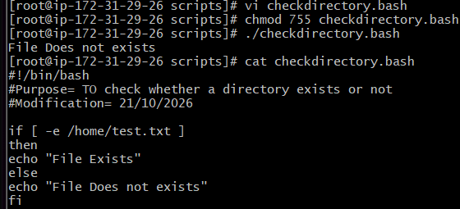
2. Create a bash script to create multiple files.
TO check multiple files we have to use Case Statement not Conditional statement.
#!/BIN/BASH
Echo
Echo Please choose one of the options below
Echo
Echo ‘a = Display Date and Time
Echo ‘b = List file and directories
Echo ‘c = List users logged in’
Echo ‘d = Check System Updates’
Echo
Read choices
Case $choices in
- date ;;
- ls;;
- who;;
- uptime;;
*) echo invalid choice – Bye
esac
case $variable in
1)
commands
;;
2)
commands
;;
*)
commands
;;
esac
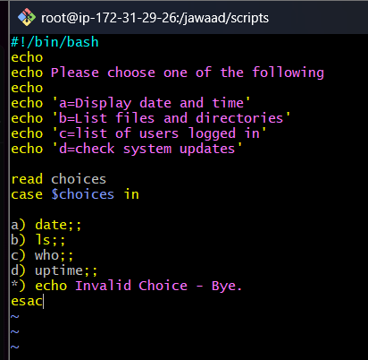
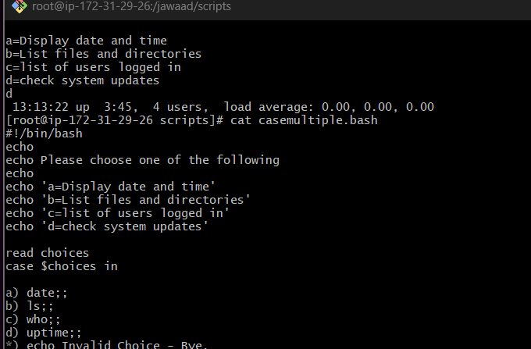
3. Create a bash script to take a backup of a directory.
Press i → Write script
│
│ #!/bin/bash
│
│ echo "Enter directory name:"
│ read ieltsfiles
│
│ if [ -d "$ieltsfiles" ]
│ then
│ tar cvf ieltsfiles.tar "$ieltsfiles"
│ echo "Backup completed"
│ else
│ echo "Directory does not exist"
│ fi
│
├── 7. Esc → :wq → Enter
│ └── Save and exit
│
├── 8. chmod 755 backup.sh
│ └── Give execution permission
│
├── 9. ./backup.sh
│ └── Execute the script
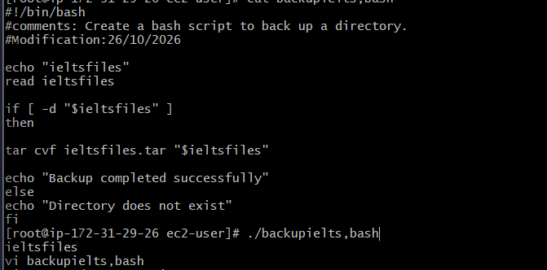
4. Create a bash script to install Nginx on an EC2 server.
Check for the Os release
cat /etc/os-release
create a vi file
Write the script
#!/bin/bash
Comments
Modification
Echo “Installing Nginx”
sudo dnf install nginx -y
If [ $? -eq 0]
Then
Echo “ Nginx is installed successfully”
Systemctl start nginx
Systemctl status nginx
Else
Echo “Nginx installation failed”
Fi
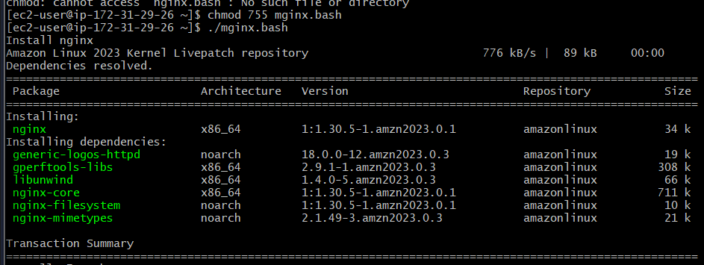
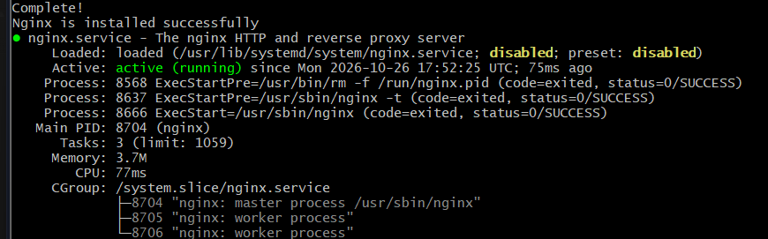
5. Create a bash script to install Apache Tomcat on an EC2 server.
First check for Java version
sudo dnf install java-21-amazon-corretto-headless -y
If [ $? -eq 0]
Then
Echo “Java installed successfully’
Java -version
Else
Echo ‘Java installation failed”
Exit 1
Fi
Echo “Downloading Tomcat”
Wegt https://
Echo “Extracting Tomcat’
Tar xvf apache-tomcat-10.1.52.tar.gz || exit 1
Echo “starting tomcat”
Cd apache-tomcat
./bin/startup.sh
If [ $0? -eq 0]
Then
echo “tomcat has started “
Else “tomcat failed to stat”
fi
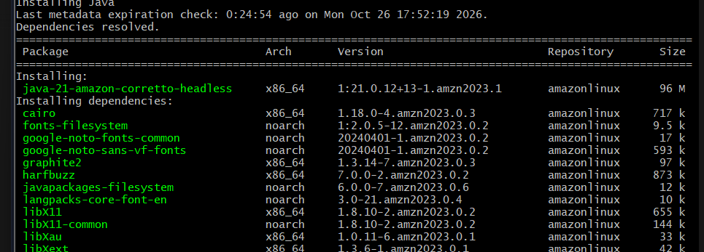
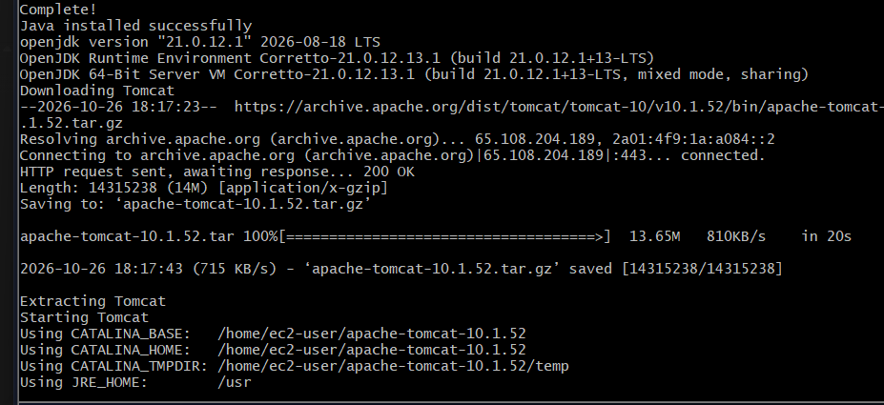
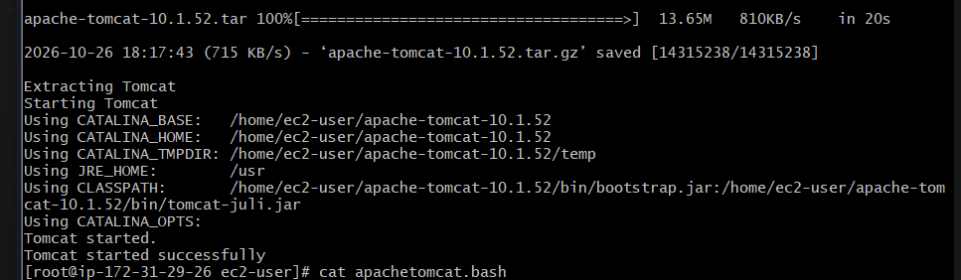
6. Create a bash script to check if the Nginx service is running, if not running then script should start the service.
Aim: To check whether Nginx is running and automatically start the service if it is stopped.
Steps Performed
Step 1: Connected to the AWS EC2 server and switched to the root user.
sudo su
Step 2: Created a Bash script using the vi editor.
vi nginxservice.bash
Step 3: Wrote the following Bash script:
#!/bin/bash
#comments: To check whether Nginx is running.
#Modification: 26/10/2026

echo "Nginx is running or not"
sudo systemctl status nginx

if [ $? -eq 0 ]
then
echo "nginx is running successfully"
else
sudo systemctl start nginx
sudo systemctl status nginx

if [ $? -eq 0 ]
then
echo "nginx is running successfully subsequent to start"
else
echo "nginx has failed to start"
fi
fi
Explanation of the Script
- #!/bin/bash – Specifies the Bash interpreter.
- echo – Displays a message on the terminal.
- systemctl status nginx – Checks the current Nginx service status.
- if [ $? -eq 0 ] – Checks whether the previous command executed successfully.
- then – Displays a success message if Nginx is running.
- else – Executes when Nginx is not running.
- systemctl start nginx – Attempts to start the Nginx service.
- Second if – Checks whether Nginx started successfully.
- fi – Closes each if statement.
Execution
Step 4: Saved the script using Esc → :wq → Enter.
Step 5: Assigned execution permissions.
chmod 755 nginxservice.bash
Step 6: Executed the script.
./nginxservice.bash
Step 7: Verified the Nginx service status.
sudo systemctl status nginx
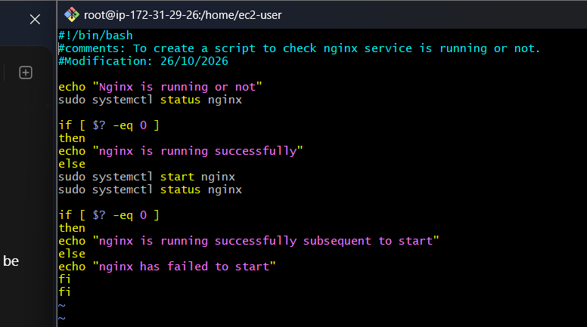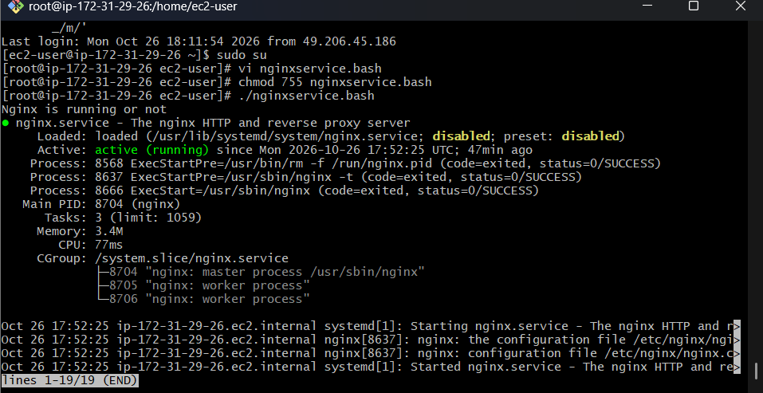
7. Create a bash script for a calculator.
Aim: To create a Bash script that performs addition, subtraction, multiplication, and division.
Steps Performed
Step 1: Connected to the AWS EC2 Linux server and created a Bash script using the vi editor.
vi calculator.bash
Step 2: Pressed i to enter insert mode and wrote the following script.
#!/bin/bash
#Description: Simple Calculator

echo "Enter first number:"
read a

echo "Enter second number:"
read b

echo "1. Addition"
echo "2. Subtraction"
echo "3. Multiplication"
echo "4. Division"

echo "Enter your choice:"
read choice

case $choice in
1) echo "Result = $((a+b))" ;;
2) echo "Result = $((a-b))" ;;
3) echo "Result = $((a*b))" ;;
4) if [ "$b" -eq 0 ]
then
echo "Cannot divide by zero"
else
echo "Result = $((a/b))"
fi ;;
*) echo "Invalid choice" ;;
esac
Step 3: Explanation of the Script
- echo – Displays messages and calculator options.
- read a and read b – Accept two numbers from the user.
- read choice – Accepts the selected operation.
- case – Executes the operation selected by the user.
- $(( )) – Performs arithmetic calculations.
- if – Prevents division by zero.
- esac – Ends the case statement.
Step 4: Saved the script using Esc → :wq → Enter.
Step 5: Assigned execution permissions.
chmod 755 calculator.bash
Step 6: Executed the Bash script.
./calculator.bash
Step 7: Entered two numbers and selected an arithmetic operation to verify the result.
Evidence
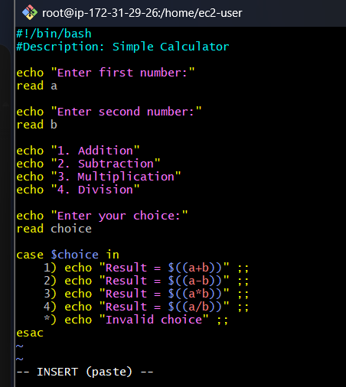
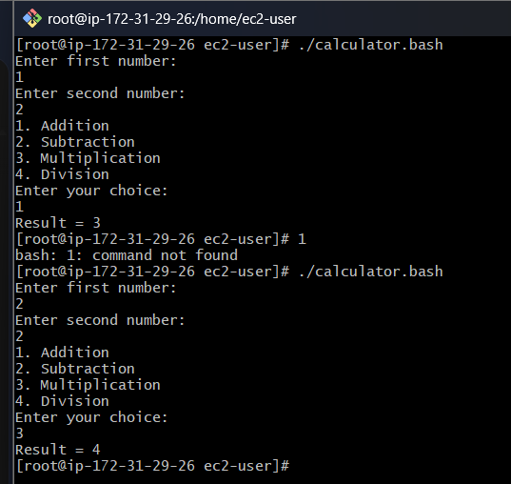
8. Create a bash script to check if a directory exists, if not then create a directory.
Aim: To create a Bash script that checks whether a directory exists and creates it if it does not exist.
Steps Performed
Step 1: Connected to the AWS EC2 Linux server and created a Bash script.
vi newdirectory.bash
Step 2: Pressed i and wrote the Bash script using the following commands:
- echo – Displays messages.
- read ieltsfilez – Accepts the directory name from the user.
- if [ -d "$ieltsfilez" ] – Checks whether the directory exists.
- mkdir "$ieltsfilez" – Creates the directory if it does not exist.
- if [ -d "$ieltsfilez" ] – Verifies whether the directory was created.
- ls -ld "$ieltsfilez" – Displays the directory details.
- fi – Closes the conditional statements.
Step 3: Saved the script using Esc → :wq → Enter.
Step 4: Assigned execution permissions.
chmod 755 newdirectory.bash
Step 5: Executed the Bash script.
./newdirectory.bash
Evidence:
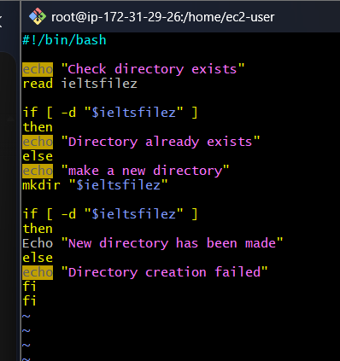
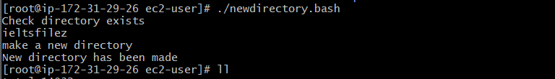
9. Create a bash script to delete the last 3 lines of a file.
Aim: To create a Bash script to delete the last three lines of a file using the sed command.
Steps Performed
Step 1: Created a sample file using the vi editor and entered 10 lines of data.
vi sample.txt
Step 2: Verified the contents of the file.
cat sample.txt
Step 3: Created a Bash script named delete.bash.
vi delete.bash
Step 4: Pressed i and wrote the following Bash script.
#!/bin/bash
#Description: Delete the last 3 lines of a file

echo "Enter file name:"
read file

if [ -f "$file" ]
then
sed -i '$d' "$file"
sed -i '$d' "$file"
sed -i '$d' "$file"

if [ $? -eq 0 ]
then
echo "Last 3 lines deleted successfully"
else
echo "Failed to delete lines"
fi
else
echo "File does not exist"
fi
Step 5: Used the following commands in the script:
- read file – Accepts the filename from the user.
- if [ -f "$file" ] – Checks whether the file exists.
- sed -i '$d' "$file" – Deletes the last line; repeated three times to delete three lines.
- if [ $? -eq 0 ] – Checks the exit status of the final sed command.
- echo – Displays success or failure messages.
- fi – Closes the conditional statements.
Step 6: Saved the script using Esc → :wq → Enter.
Step 7: Assigned execution permissions.
chmod 755 delete.bash
Step 8: Executed the Bash script.
./delete.bash
Step 9: Entered the filename when prompted.
Enter file name:
sample.txt
Step 10: Verified the updated file contents.
cat sample.txt
Expected Output:
1
2
3
4
5
6
7
Result
Successfully created and executed a Bash script to delete the last three lines of sample.txt using the sed command. Verified the remaining seven lines using cat sample.txt.
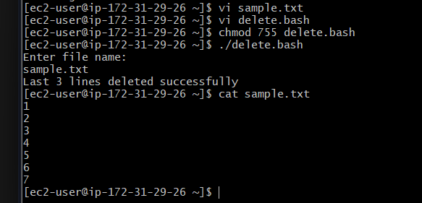
10. Bash script to monitor cpu and if it is more than 80% then send email notification.
Steps Performed
- Connected to the AWS EC2 Linux server.
- Created a Bash script to monitor CPU usage.
- Defined the CPU threshold as 80% and specified the recipient's email address.
- Used a continuous loop to monitor CPU usage repeatedly.
- Used CPU monitoring and text-processing utilities to calculate the current CPU usage percentage.
- Applied an if-condition to check whether CPU usage exceeded 80%.
- Configured the script to attempt an email notification when CPU usage exceeded the threshold.
- Added a 60-second interval between CPU checks.
- Saved the script, assigned execution permissions, and executed it.
- Observed the CPU monitoring output and stopped the script using Ctrl + C.
Result
Successfully executed the CPU monitoring script. However, the CPU calculation displayed 100% incorrectly, and the email notification failed because the mail delivery service was not configured.
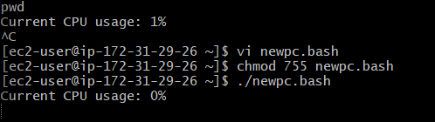
11. Bash script to monitor disk space and if it is more than 80% then send email notification.
Steps Performed
- Connected to the AWS EC2 Linux server.
- Checked the current disk space utilization.
- Created a Bash script named disk.bash.
- Defined the disk usage threshold as 80% and specified the recipient's email address.
- Used a continuous loop to monitor disk usage repeatedly.
- Used disk monitoring and text-processing utilities to extract the disk usage percentage.
- Applied an if-else condition to check whether disk usage exceeded 80%.
- Configured the script to attempt an email notification when disk usage exceeded the threshold.
- Added a 60-second interval between disk usage checks.
- Saved the script and assigned execution permissions.
- Executed the Bash script and monitored the disk usage output.
- Stopped the script using Ctrl + C.
Result
Successfully created a Bash script to continuously monitor disk space and attempt an email notification when disk usage exceeds 80%. Actual email delivery requires a configured mail service.
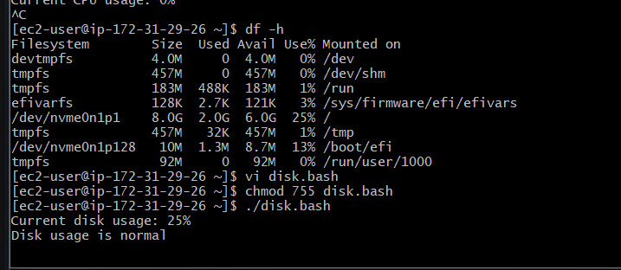
12. Bash script to monitor memory and if it is more than 80% then send email notification.
Steps Performed
Step 1: Connected to the AWS EC2 Linux server and checked the available and used memory.
Step 2: Created a Bash script named memory.bash using the vi editor.
Step 3: Defined the memory usage threshold as 80% and specified the recipient's email address.
Step 4: Used a while true loop to monitor memory usage continuously.
Step 5: Used the free command to collect memory information and awk to calculate the memory usage percentage.
Step 6: Used an if-else condition to check whether memory usage exceeded 80%.
Step 7: Added the mail command to attempt an email noti
#!/bin/bash
#Description: Monitor memory and send email above 80%

THRESHOLD=80
EMAIL="yourmail@example.com"

while true
do
memory=$(free | awk '/^Mem:/ {printf "%.0f", ($2-$7)/$2*100}')

echo "Current memory usage: $memory%"

if [ "$memory" -gt "$THRESHOLD" ]
then
echo "Memory usage is $memory%" | mail -s "Memory Alert" "$EMAIL"
else
echo "Memory usage is normal"
fi

sleep 60
done
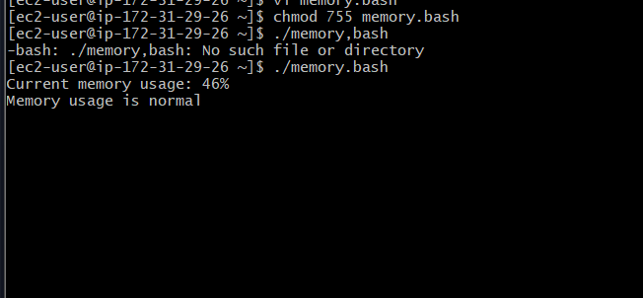
Exercise: Crontab Entries

1. April 5th Midnight

2. 5th of Every November, January, June if it is a Thursday

3. At 05 and 27th minutes of 9, 10, 11 hours every day

4. 34 minutes of 9th hour on 15th August

5. Every midnight

6. Every Weekend (Saturday night 11:59 PM)

7. After every reboot
Steps Performed
Step 1: Connected to the AWS EC2 Linux server and started the Cron service.
sudo systemctl start crond
Step 2: Enabled the Cron service to start automatically after reboot.
sudo systemctl enable crond
Step 3: Verified that the Cron service was running.
sudo systemctl status crond
Step 4: Opened the Crontab editor to schedule tasks.
crontab -e
Step 5: Pressed i to enter INSERT mode and added the following seven Cron jobs.
# 1. April 5th at midnight
0 0 5 4 * date >> /tmp/cron1.log

# 2. 5th of January, June and November, only if Thursday
0 0 5 1,6,11 * [ "$(date +\%u)" -eq 4 ] && date >> /tmp/cron2.log

# 3. At 05 and 27 minutes of 9, 10 and 11 AM
5,27 9,10,11 * * * date >> /tmp/cron3.log

# 4. August 15th at 9:34 AM
34 9 15 8 * date >> /tmp/cron4.log

# 5. Every midnight
0 0 * * * date >> /tmp/cron5.log

# 6. Every Saturday at 11:59 PM
59 23 * * 6 date >> /tmp/cron6.log
# 7. After every reboot
@reboot date >> /tmp/cron7.log
